**Visualization tool for electric charging and range analysis**

**Introduction**

**1.Overview**

The City of Surrey is in the early stages of developing an electric vehicle strategy as part of its approach

to reducing greenhouse gas (GHG) emissions. Due to limited public transit and low-density development, Surrey is highly auto-dependent, with 60% of its GHG emissions coming from transportation (City of Surrey, 2018). Additionally, Surrey is growing rapidly, increasing in population by 10.6% in last census period compared to 6.5% for the Metro Vancouver area and 5% for Canada as a whole (Statistics Canada,2016). Growth is expected to continue, with Surrey becoming the largest city in the Metro Vancouver region with over 800,000 residents by 2040 (City of Surrey, 2017; Western Investor, 2017). Surrey is currently planning how to support this projected rapid growth to design a sustainable and livable city.

A variety of factors make electric vehicles (EVs) attractive to consumers in the Metro Vancouver area.

In other regions, the electricity used to charge vehicles comes from fossil-fuel reliant power plants, which

result in electric vehicles having less than half of the lifetime emissions of a standard gasoline powered

vehicle (Union of Concerned Scientists, 2015). However, 93% of electricity generated in British Columbia

comes from renewable sources, resulting in nearly emission-free charging (City of Vancouver, 2019). Over

90% of BC’s power comes from hydro-electricity whose abundance leads to competitive electricity rates,

which in combination with the region’s high gas prices make electric vehicles attractive to consumers

(Government of Canada, 2019; DeMuro, 2019). Electric vehicles offer additional benefits including lower

lifetime maintenance costs, better safety ratings, dedicated parking spots, and unrestricted HOV lane

use (City of Vancouver, 2019; DeMuro, 2019). While electric vehicles offer many benefits, they currently

make up less than 1% of the total vehicle stock in Surrey and face a variety of challenges to reaching

widespread adoption.

**2.Purpose**

The Province of British Columbia has passed legislation requiring all vehicles sold by 2040 to be zero

emission and Surrey has set the goal of converting its entire passenger vehicle stock to zero-emission

vehicles by 2050 (Province of British Columbia, 2018). To achieve these goals, the City of Surrey plans

to support EV adoption through direct approaches such as building charging infrastructure, creating

city fleet requirements, and simplifying the permitting and installation process for chargers as well as

educational efforts to make consumers aware of the benefits of electric vehicles as well as rebates

programs to reduce the upfront cost. To develop a successful Electric Vehicle Strategy, Surrey needs

to understand both the state of Surrey’s vehicle stock and charging infrastructure and the social and

economic landscape of the ccity

**Problem definition and design thinking**

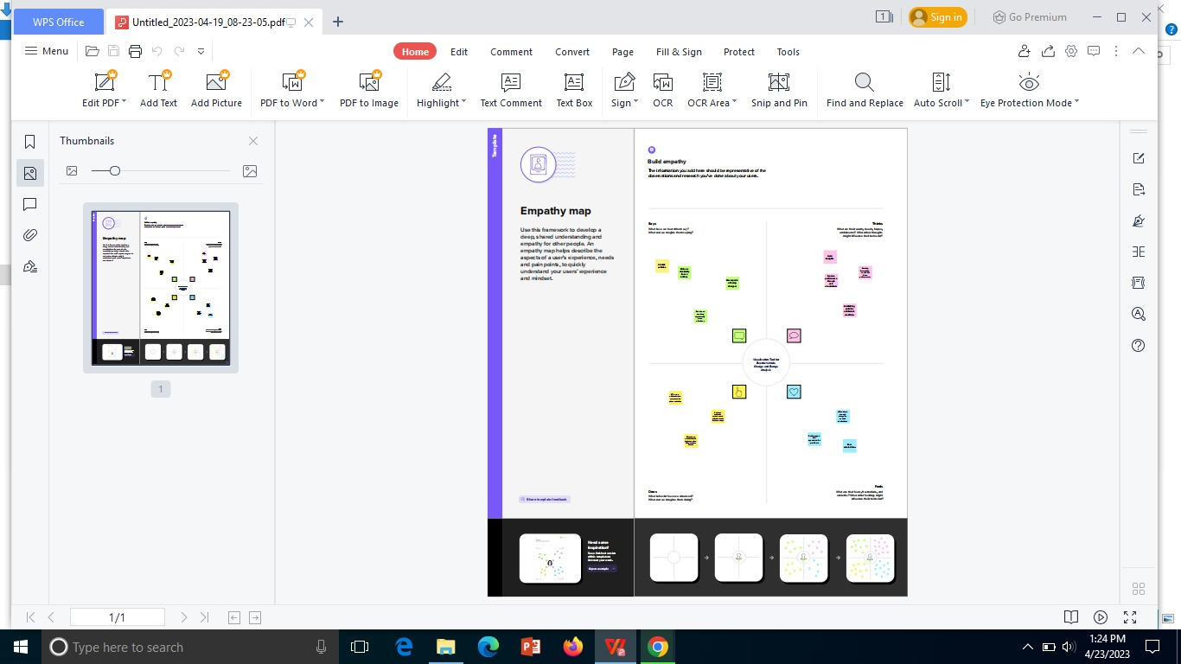2.**Empathy map**

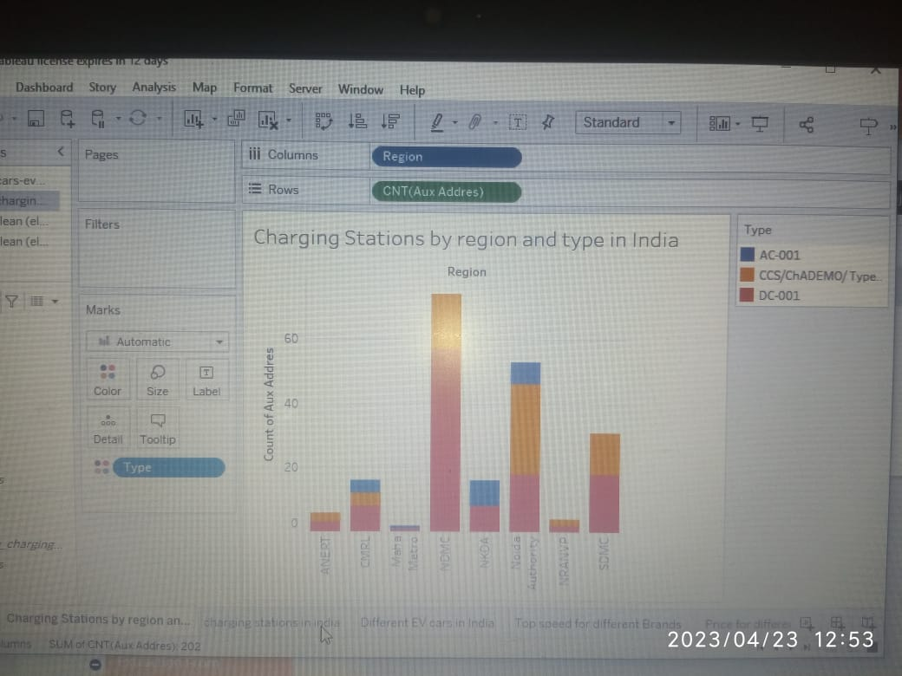

**3 Results**

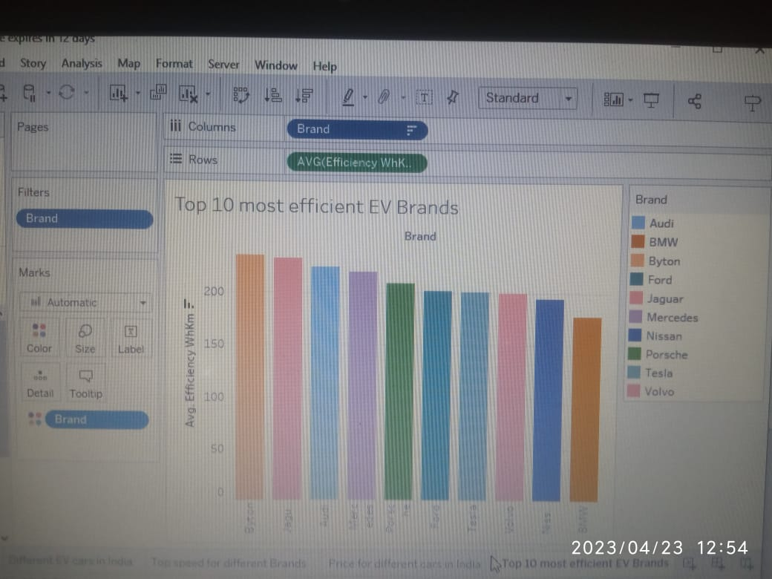

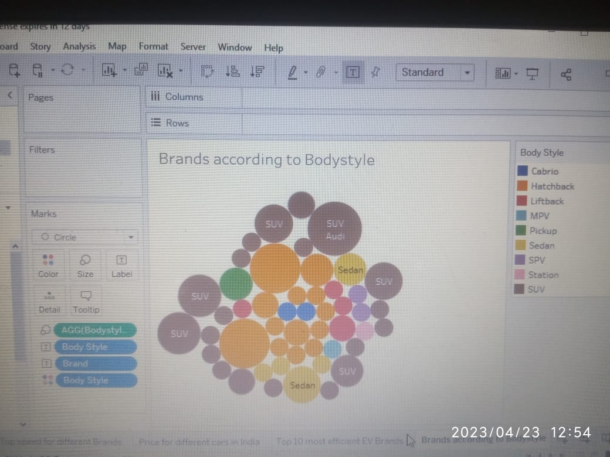

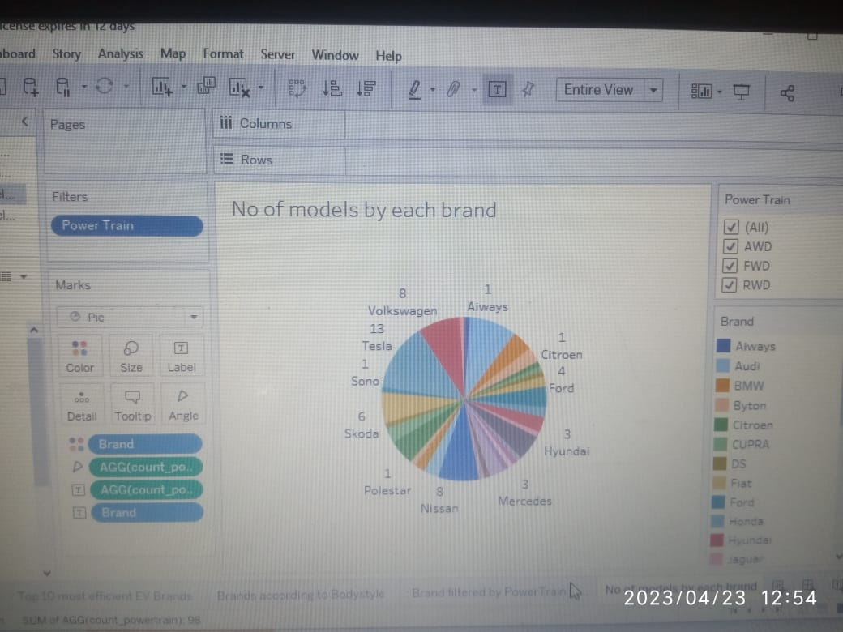

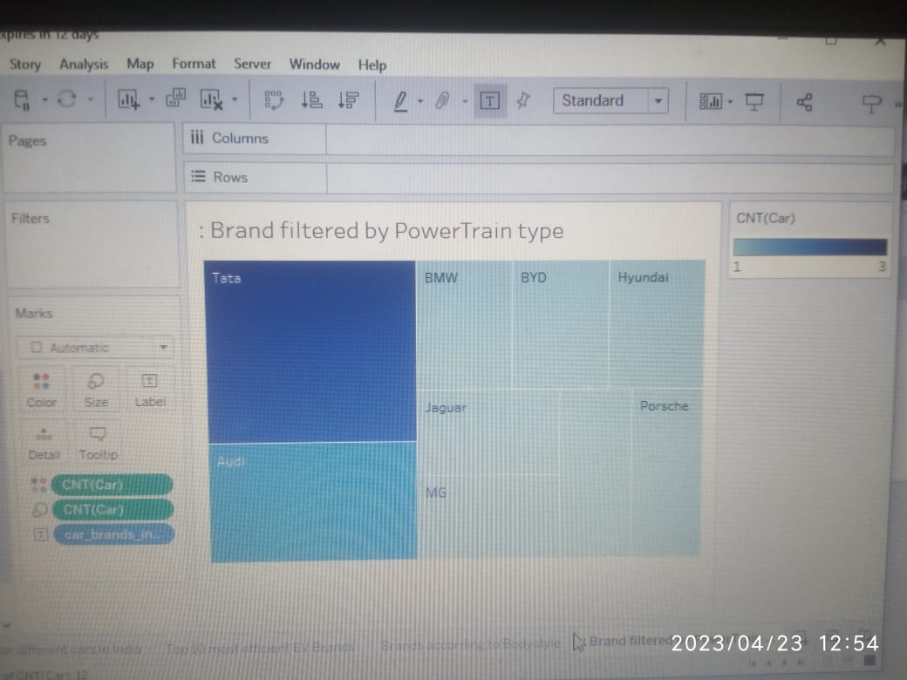

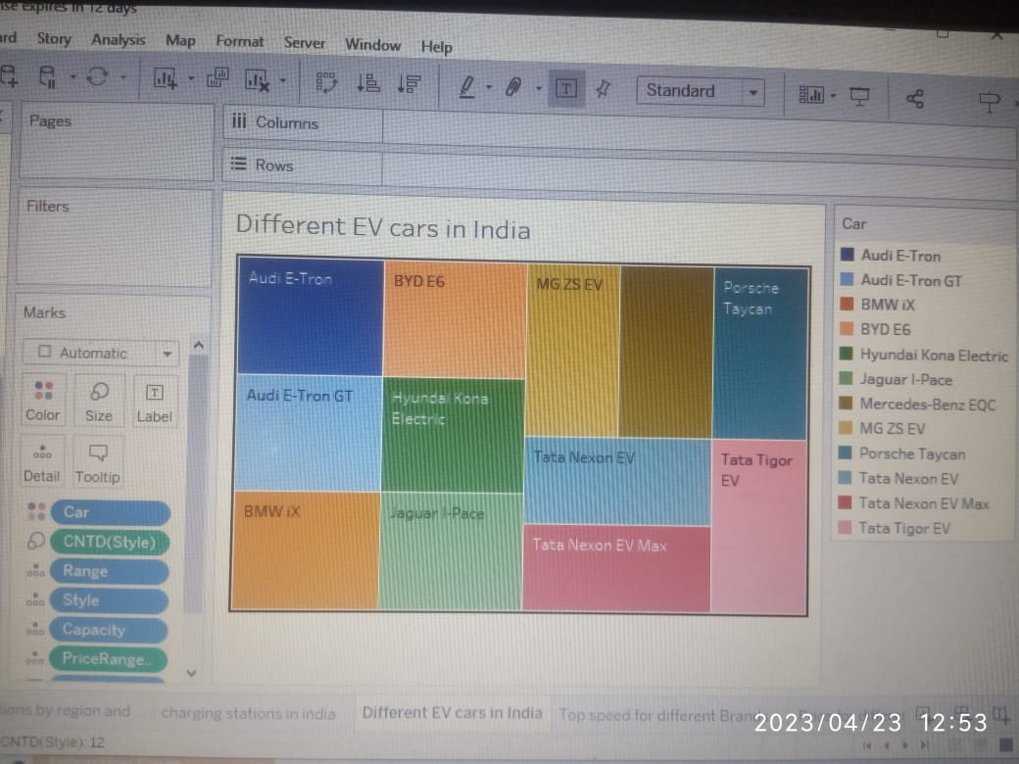

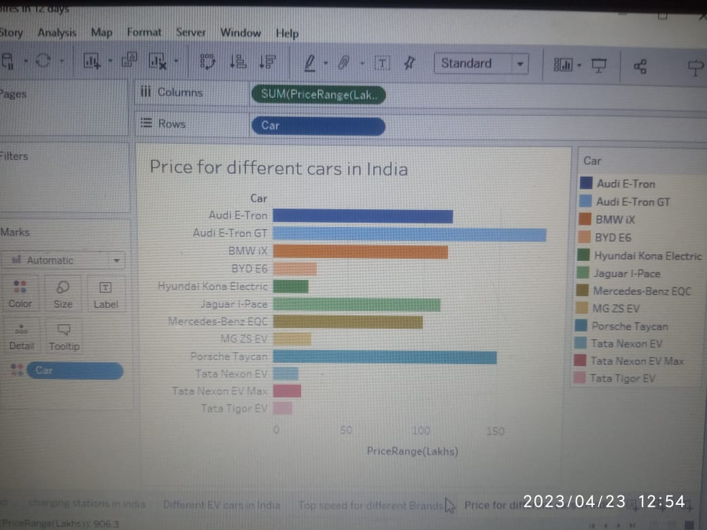

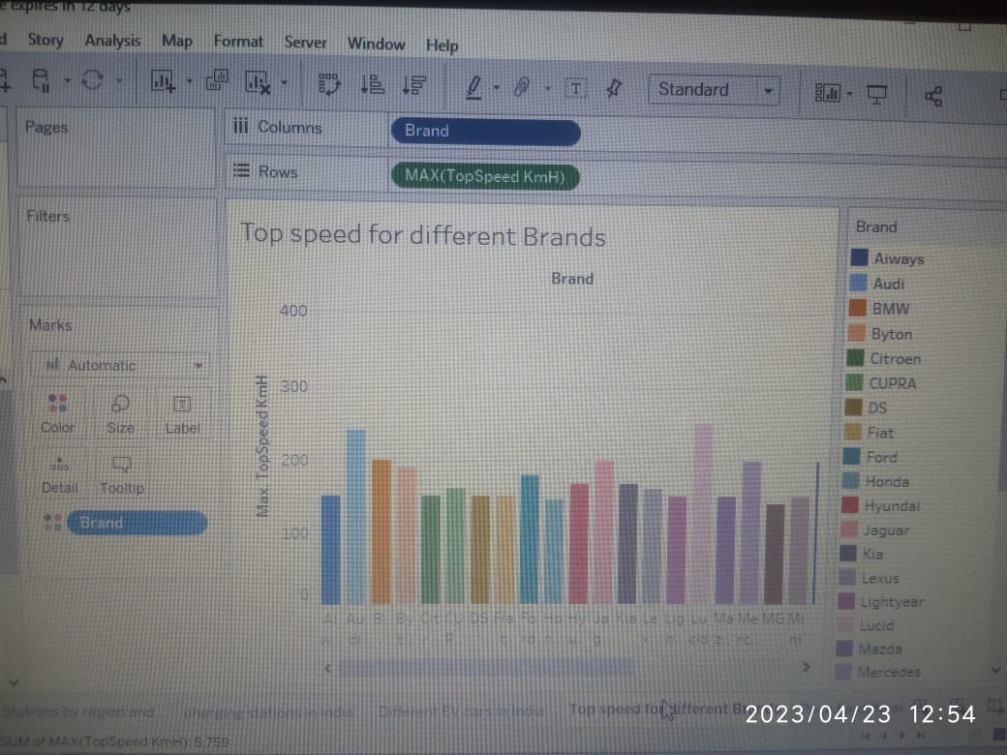

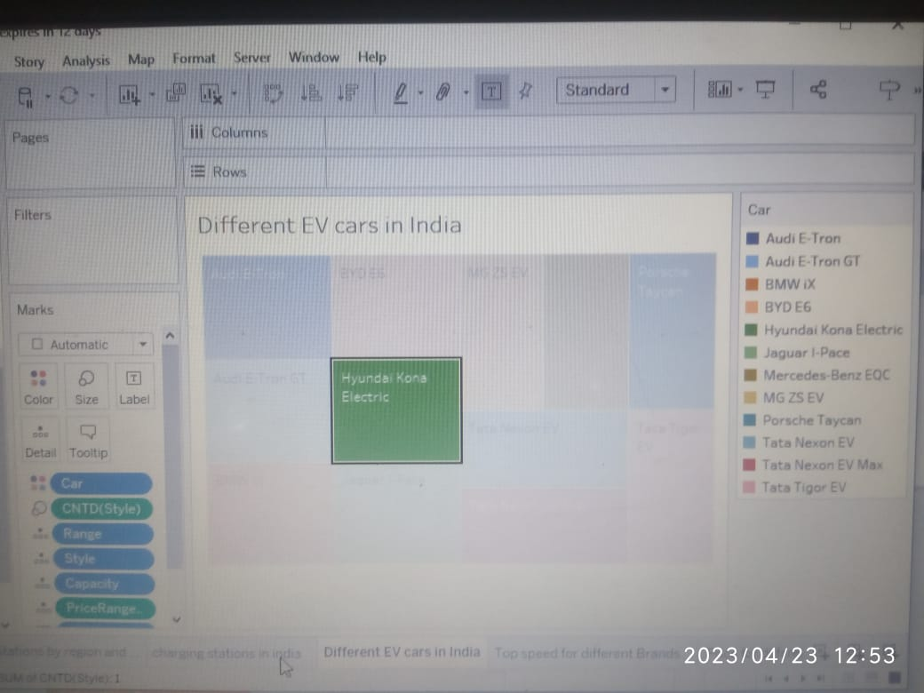

**Advantages of Data Visualization :**

**Better agreement**

In business numerous a period it happens that we need to look at the exhibitions of two components or two situations. A conventional methodology is to experience the massive information of both the circumstances and afterward examine it. This clearly will kill a great deal of time.

**A superior method**

It can tackle the difficulty of placing the information of both perspectives into the pictorial structure. This will unquestionably give a superior comprehension of the circumstances. For instance, Google patterns assist us with understanding information identified with top ventures or inquiries in pictorial or graphical structures.

**Simple sharing of data**

With the representation of the information, organizations present another arrangement of the correspondence. Rather than sharing the cumbersome information, sharing the visual data will draw in and pass on across the data which is more absorbable.

**Disadvantages of Data Visualization :**

**It gives assessment not exactness**

While the information is exact in foreseeing the circumstances, the perception of similar just gives the assessment. It without a doubt is anything but difficult to change over the robust and protracted information into simple pictorial configuration yet such a portrayal of data may prompt theoretical ends now and then.

**One-sided**

The essential arrangement of information representation occurs with the human interface, which means the information that turns out to be the base of perception can be one-sided. The individual bringing the information for the equivalent may just think about the significant part of the information or the information that requirements center and may reject the remainder of the information which may prompt one-sided results.

**Absence of help**

One of the downsides of information perception is that it can’t help, which means an alternate gathering of the crowd may decipher it in an unexpected way.

**Application**

Visual Basic for Applications is a computer programming language developed and owned by Microsoft. With VBA you can create macros to automate repetitive word- and data-processing functions, and generate custom forms, graphs, and reports.

**Conclusion**

Through the current project, UCLA SMERC has successfully developed and demonstrated the advanced technologies to achieve the goals of the project: PEV Smart Charging and Storage in Supporting Grid Operational Needs. This section describes the conclusions from the project, the lessons learned and key obstacles encountered through the project.

**Future Scope**

One topic that has not been visualized and has only been mentioned in the facts and general content section of the final project is the context of renewable energy. As mentioned several times throughout the report, the goal of reducing CO2 emissions is one of the main driving factors of Emobility [5] [6] [9]. Possible topics that could be discussed and visualized are:

**Ideation and brainstroming**

